Scholarship Application
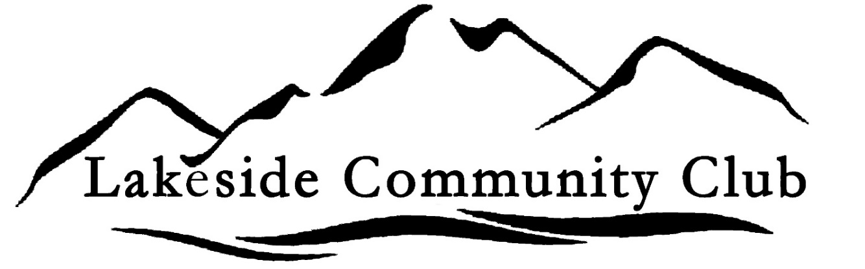
Scholarship Information;

Mission
Our Lakeside Community Club, was established in 1909, to form a better spirit of neighborliness and cooperation for the better of the Club, community, and fellow members. Our scholarship mission is to support and assist in the development of our local residents planning to work attend school and work in our communities throughout Montana.

History
In 2024, we started with our West Shore community scholarship awards.

Amount
In 2026, the minimum amount will be $1000.

Applicant qualifications
- Current Flathead West Shore resident at time of scholarship award.
- OR a previous Lakeside or Somers student.
- Plan to attend a trade school, college, or university for a degree (Trade Certificate, Associate, Bachelor, etc.). Registering for school in current year 2026.

Lakeside Community Club scholarship applications submitted, must include the following documentation:
- Two (2) letters of reference from non-relatives who can attest to your personal achievements and positive contribution to the community.
- Copy of most recent school transcript.
- Proof of school admission or acceptance.
- Resume of education, community service, extra curricular activities, work experience, honors or any recognition received.
- Your written description of future plans (approx. 250 words) for education & work experience.

Deadline Friday, April 3rd, 2026

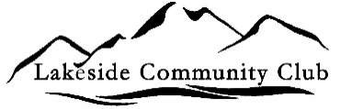
Send or deliver application with attachments to either:
Your High School career center or counselor.
<<< OR >>>
Lakeside Community Club
Attn: Scholarship
P.O. Box 481
Lakeside, MT 59922
carolnelson@carolnelsondesign.com

Full Name: _____________________________________________________________

Cell phone: (____)_____-________ Alternate phone: (____)_____-___________

Email Address: _________________________________________________________

Mailing Address: ________________________________________________________
________________________________________________________________
Physical Address: _______________________________________________________
________________________________________________________________

Are you currently a West Shore area resident? _________ Which community? ________

OR are you a previous Lakeside / Somers student? _______ Years of attendance: _____

High School you attend: _______________________ Cumulative GPA ______ (Copy transcript)

University/College/School you plan attend: UM MSU FVCC Other: __________________

Have you been accepted for admission? If, Yes_____ As of what date? ________ (provide letter)
Not yet _____ Explain: ______________________

What is your desired degree or area of study?
1st Choice _________________________________________
2nd________________________________________________
3rd ________________________________________________

I verify that all of the above is true, and legitimate. I also understand that by filling out the above application, I am not ensured to receive any financial help.

Deadline Friday, April 3, 2026

__________________________________________________ ____________________
Student Signature Date

